COMP2190 Project

on

Socket Programming



Name: Jon-Daniel Coombs (620142113)

Course Code: COMP2190

Test Cases

**Contents**

**AGENT A** 3

Test Case #1 – AJK782975 4

Figure 1. Server Log of Test Case 1 being completed 4

Figure 2. Client Log of Test Case 1 being completed 5

Test Case #2 – KTV902975 6

Figure 3. Server Log of Test Case 2 being completed 6

Figure 4. Client Log of Test Case 2 being completed 7

Test Case #3 – NEL552975 8

Figure 5. Server Log of Test Case 3 being completed 8

Figure 6. Client Log of Test Case 3 being completed 9

Test Case #4 – DFG282975 10

Figure 7. Server Log of Test Case 4 being completed 10

Figure 8. Client Log of Test Case 4 being completed 11

**AGENT B** 12

Test Case #5 – AJK786144 13

Figure 9. Server Log of Test Case 5 being completed 13

Figure 10. Client Log of Test Case 5 being completed 14

Test Case #6 – KTV906144 15

Figure 11. Server Log of Test Case 6 being completed 15

Figure 12. Client Log of Test Case 6 being completed 16

Test Case #7 – NEL556144 17

Figure 13. Server Log of Test Case 7 being completed 17

Figure 14. Client Log of Test Case 7 being completed 18

Test Case #8 – DFG286144 19

Figure 15. Server Log of Test Case 8 being completed 19

Figure 16. Client Log of Test Case 8 being completed 20

# **AGENT A**

# Test Case #1 – AJK782975

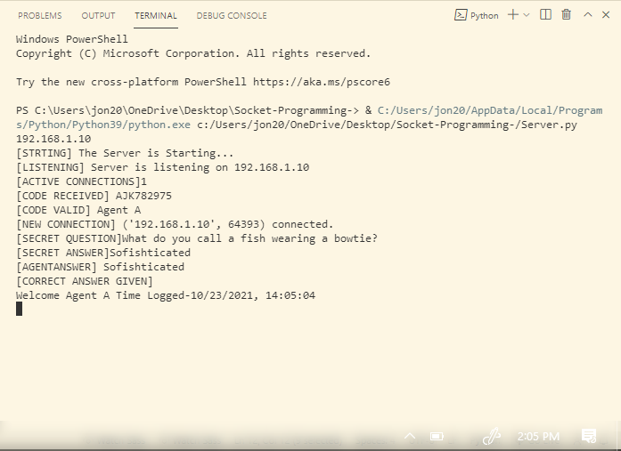

## Figure 1. Server Log of Test Case 1 being completed

## Figure 2. Client Log of Test Case 1 being completed

# Test Case #2 – KTV902975

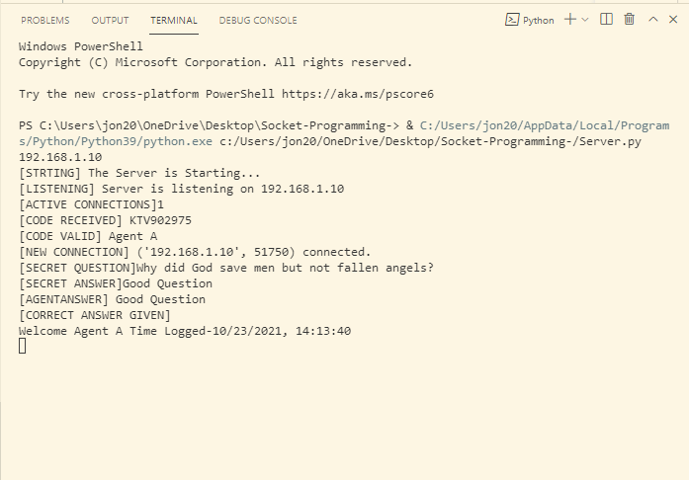

## Figure 3. Server Log of Test Case 2 being completed

## Figure 4. Client Log of Test Case 2 being completed

# Test Case #3 – NEL552975

## Figure 5. Server Log of Test Case 3 being completed

## Figure 6. Client Log of Test Case 3 being completed

# Test Case #4 – DFG282975

## Figure 7. Server Log of Test Case 4 being completed

## Figure 8. Client Log of Test Case 4 being completed

# **AGENT B**

# Test Case #5 – AJK786144

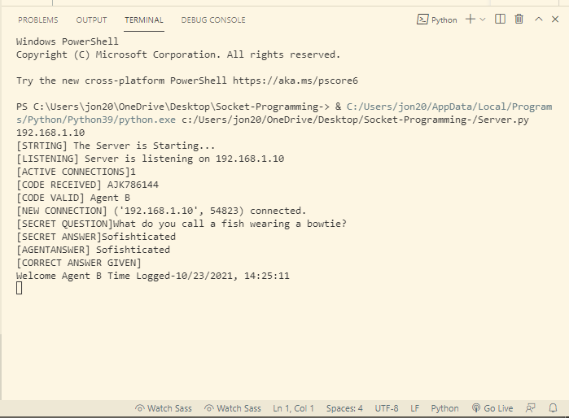

## Figure 9. Server Log of Test Case 5 being completed

## Figure 10. Client Log of Test Case 5 being completed

# Test Case #6 – KTV906144

## Figure 11. Server Log of Test Case 6 being completed

## Figure 12. Client Log of Test Case 6 being completed

# Test Case #7 – NEL556144

## Figure 13. Server Log of Test Case 7 being completed

## Figure 14. Client Log of Test Case 7 being completed

# Test Case #8 – DFG286144

## Figure 15. Server Log of Test Case 8 being completed

## Figure 16. Client Log of Test Case 8 being completed

# Test Case #9 – Two instances of Client connecting to Server

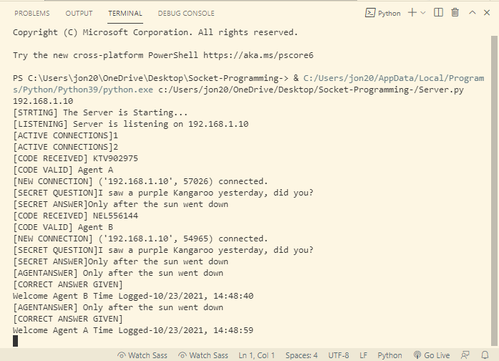

## Figure 17. Server Log of Test Case 9 being completed

## Figure 16. Client Log of first instance of Test Case 8 being completed

## Figure 17. Client Log of second instance of Test Case 8 being completed